**Melody / Pitch:**

*The Ranges of common orchestral instruments (in score order)*

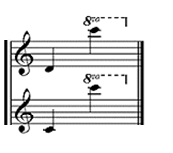

Piccolo:

Flute:

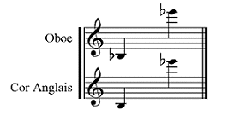

Oboe:

Cor Anglais:

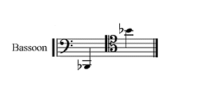

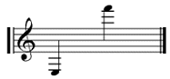Bassoon:

Professionals could be expected to play to a high B above this.

Clarinet in Bb:

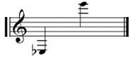

Bass Clarinet in Bb:

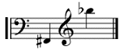

French Horn in F:

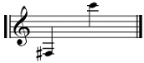

Trumpet in Bb:

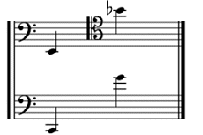

Professionals could be expected to play to a high F above this.

Tenor Trombone:

Bass Trombone:

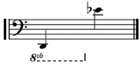

Tuba:

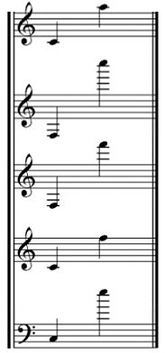Glockenspiel:

Xylophone:

Vibraphone:

Tubular Bells:

Marimba:

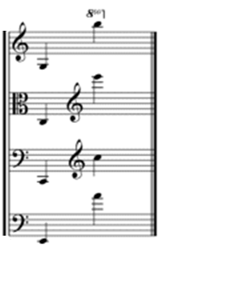

Violin:

Viola:

Violoncello (‘cello):

Double Bass:

**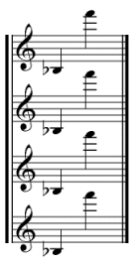***Other common instruments:*

Soprano Saxophone:

Alto Saxophone:

Tenor Saxophone:

Baritone Saxophone:

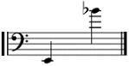Euphonium:

*Voices:*

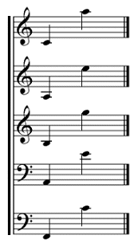

Soprano:

Alto:

Tenor:

Baritone:

Bass:

**Contour:**

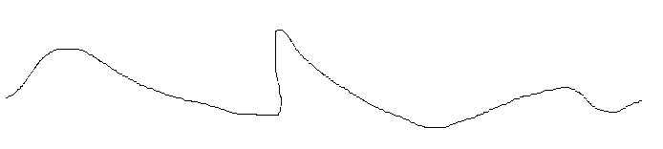The contour of a melody refers to the approximate shape, that is when it is going up and down and by how much. It is usually notated by drawing a line, e.g.

This would be a melody which increases and then gradually decreases in pitch before jumping up even higher. It then decreases and gradually increases, ending by dipping down and returning to a similar pitch to its beginning.

Good words to describe contour include:

|  |  |  |  |
| --- | --- | --- | --- |
| * Chromatic * Leaps | * Diatonic * Steps | * Intervals   (large or small) | * Angular * Flowing |

**Scales:**

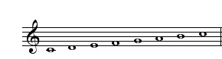*Major (in circle of fifths):*

C major:



G major:



D major:



A major:



E major:



B major:

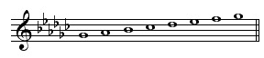

F# major:

(Gb major)



Db major:

(C# major)



Ab major:



Eb major:



Bb major:



F major:

*Harmonic Minor:*

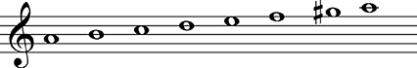

A minor:

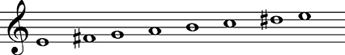

E minor:

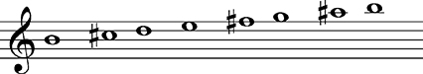

B minor:

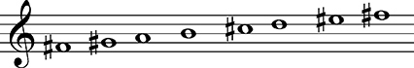

F# minor:

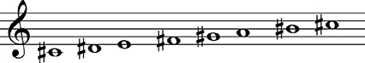

C# minor:

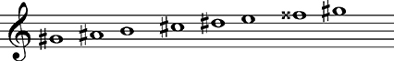

G# minor:

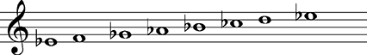

Eb minor:

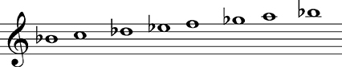

Bb minor:

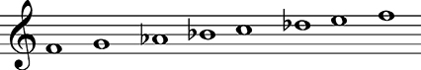

F minor:

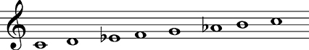

C minor:

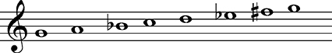

G minor:

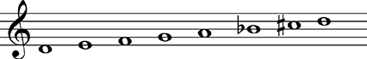

D minor:

*Modes (only related to C major)*

C major:



D Dorian:



E Phrygian:



F Lydian:



G Mixolydian:



A Aeolian:



B Locrian: